Python If ... Else

Python Conditions and If statements
Python supports the usual logical conditions from mathematics:
expression | description
== | Equals to
!= | Not equal
> | Greater than
< | Less than
<= | Less than or equals
>= | Greater than or equals

These conditions can be used in several ways, most commonly in "if statements" and loops.
The if statement is the easiest method for making a decision in Python. It simply states that if something is true, Python should perform the steps that follow.
An "if statement" is written by using the if keyword.
When Python sees if, it knows that you want it to make a decision. After the word if comes a condition. A condition simply states what sort of comparison you want Python to make. In the case below we want to see if a is greater than b.

Example
If statement:

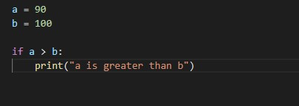
In this example we use two variables, a and b, which are used as part of the if statement to test whether a is greater than b. As a is 90, and b is 200, we know that 90 is mot greater than 100, and so nothing will we printed on the terminal.

Another example:
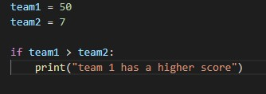
In the example above, the score of team1 is greater than that of team2 so the string “team 1 has a higher score” will be printed on the terminal.

Indentation
Python relies on indentation (whitespace at the beginning of a line) to define scope in the code. Other programming languages often use curly-brackets for this purpose.
An if statement without an indentation will raise an error. Example:
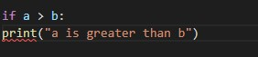

Let’s try a guess-a-number program. The computer picks a random number, the player tries to guess, and the program tells them if they are correct. To see if the player’s guess is correct, we need an if statement.
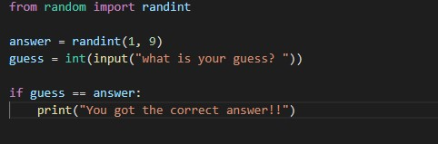

Else
The else keyword catches anything which isn't caught by the if statement.
The else code is like an exception; we can say in real life terms: if a condition is not fulfilled or is not true the else statement is what would be executed.
EXAMPLE:
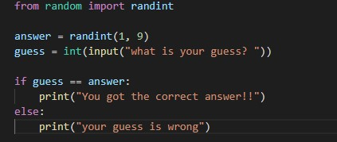

Elif
The elif keyword is pythons way of saying "if the previous conditions were not true, then try this condition".
A simple use of an if statement is to assign letter grades. Suppose that scores 90 and above are A’s, scores in the 80s are B’s, 70s are C’s, 60s are D’s, and anything below 60 is an F. This is one way to do this:
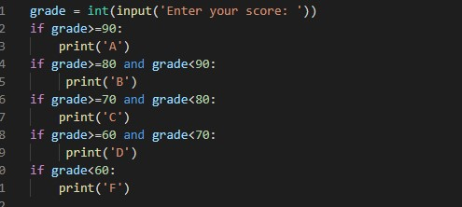
The code above works but a more efficient and neater way to have the same outcome is by using elif:
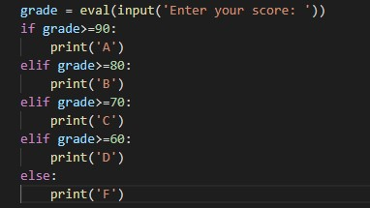

More examples of using elif:
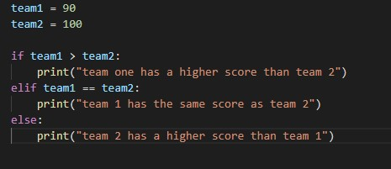
In this example, team 2 has the same score as team 1, but if their scores were equal, the elif condition would have printed “team 1 has the same score as team 2”, but in this case the if condition is fulfilled and “team one has a higher score than team 2” would be printed on the terminal.

Example

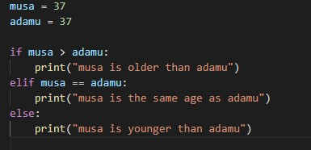
You can also have an if without an elif.

Short Hand If
If you have only one statement to execute, you can put it on the same line as the if statement.

Example
One line if statement:
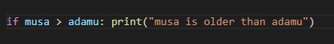

Short Hand If ... Else
If you have only one statement to execute, one for if, and one for else, you can put it all on the same line:

Example
One line if else statement:
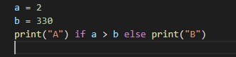
It is also possible to have multiple else statements on the same line:

Example
One line if else statement, with 3 conditions:
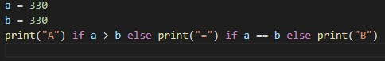

And
The and keyword is a logical operator, and is used to combine conditional statements:

Example
Test if a is greater than b, AND if c is greater than a:
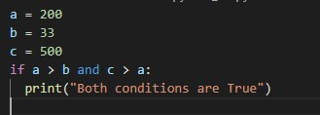

Or
The or keyword is a logical operator, and is used to combine conditional statements:

Example
Test if a is greater than b, OR if a is greater than c:
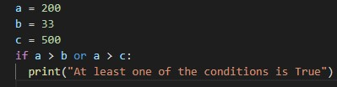

Nested If
You can have if statements inside if statements, this is called nested if statements.

Example
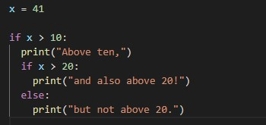

The pass Statement
if statements cannot be empty, but if you for some reason have an if statement with no content, put in the pass statement to avoid getting an error.

Example
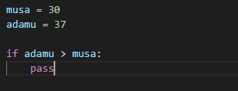ise

Python Loops
Python has two primitive loop commands:
- while loops
- for loops

The while Loop
With the while loop we can execute a set of statements as long as a condition is true.
Sometimes, though, we need to repeat something, but we don’t know ahead of time exactly how many times it has to be repeated. For instance, a game of Tic-tac-toe keeps going until someone wins or there are no more moves to be made, so the number of turns will vary from game to game. This is a situation that would call for a while loop.

Example
Print i as long as i is less than 6:
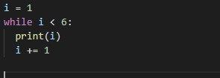
Note: remember to add the increment; in this case it is I+=1, or else the loop would run infinitely
The while loop requires relevant variables to be ready, in this example we need to define an indexing variable, i, which we set to 1.

The break Statement
With the break statement we can stop the loop even if the while condition is true:

Example
Exit the loop when i is 3:
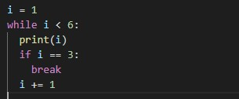

The continue Statement
With the continue statement we can stop the current iteration, and continue with the next:

Example
Continue to the next iteration if i is 3:
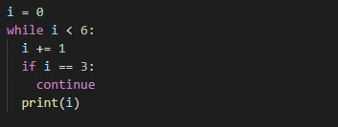

The else Statement
With the else statement we can run a block of code once when the condition no longer is true:

Example
Print a message once the condition is false:
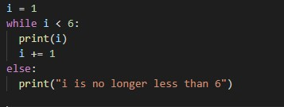

Python For Loops

Python For Loops

Probably the most powerful thing about computers is that they can repeat things over and over very quickly. There are several ways to repeat things in Python, the most common of which is the for loop.
A for loop is used for iterating over a sequence (that is either a list, a tuple, a dictionary, a set, or a string).
This is less like the for keyword in other programming languages, and works more like an iterator method as found in other object-orientated programming languages.
With the for loop we can execute a set of statements, once for each item in a list, tuple, set etc.
The structure of a for loop is as follows:
The syntax is important here. The word for must be in lowercase, the first line must end with a colon, and the statements to be repeated must be indented. Only the statements that are indented will be repeated.
The range function
The value we put in the range function determines how many times we will loop. The way range works is it produces a list of numbers from zero to the value minus one. For instance, range(5) produces five values: 0, 1, 2, 3, and 4.
If we want the list of values to start at a value other than 0, we can do that by specifying the starting value. The statement range(1,5) will produce the list 1, 2, 3, 4. This brings up one quirk of the range function—it stops one short of where we think it should. If we wanted the list to contain the numbers 1 through 5 (including 5), then we would have to do range(1,6). Another thing we can do is to get the list of values to go up by more than one at a time. To do this, we can specify an optional step as the third argument. The statement range(1,10,2) will step through the list by twos, producing 1, 3, 5, 7, 9. To get the list of values to go backwards, we can use a step of -1. For instance, range(5,1,-1) willproducethevalues5,4,3,2,inthatorder. (Note that the range function stops one short of the ending value 1). Here are a few more examples:
range | output
range(10) | 0,1,2,3,4,5,6,7,8,9
range(1,10) | 1,2,3,4,5,6,7,8,9
range(3,7) | 3,4,5,6
range(2,15,3) | 2,5,8,11,14
range(9,2,-1) | 9,8,7,6,5,4,3

Example
Print each name in a list of names:
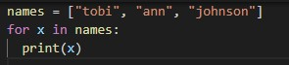
The for loop does not require an indexing variable to set beforehand.

Example1:
The code below would print “hello” ten times.
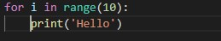

Example2:
The example below asks the user for a number ten times and each time the user inputs the number, the square of the number is printed. After the ten iterations, the string “the for loop has been terminated” would be printed on the terminal.
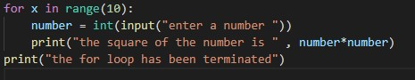

Looping Through a String
Even strings are iterable objects, they contain a sequence of characters:

Example
Loop through the letters in the word "banana":
for x in "banana":
print(x)

The break Statement
With the break statement we can stop the loop before it has looped through all the items:

Example
Exit the loop when x is "banana":
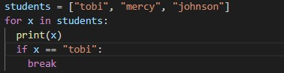

Example
Exit the loop when x is "banana", but this time the break comes before the print:
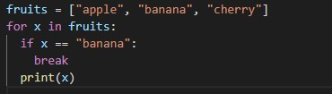
Note: in this example the output would not be “banana” but instead the output would be the value before “banana” which is “apple”.

The continue Statement
With the continue statement we can stop the current iteration of the loop, and continue with the next:

Example
Do not print banana:
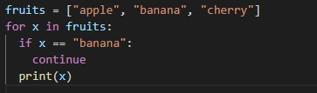

The range() Function
To loop through a set of code a specified number of times, we can use the range() function,
The range() function returns a sequence of numbers, starting from 0 by default, and increments by 1 (by default), and ends at a specified number.

Example
Using the range() function:
for x in range(6):
print(x)
Note that range(6) is not the values of 0 to 6, but the values 0 to 5.
The range() function defaults to 0 as a starting value, however it is possible to specify the starting value by adding a parameter: range(2, 6), which means values from 2 to 6 (but not including 6):

Example
Using the start parameter:
for x in range(2, 6):
print(x)
The range() function defaults to increment the sequence by 1, however it is possible to specify the increment value by adding a third parameter: range(2, 30, 3):

Example
Increment the sequence with 3 (default is 1):
for x in range(2, 30, 3):
print(x)

Else in For Loop
The else keyword in a for loop specifies a block of code to be executed when the loop is finished:

Example
Print all numbers from 0 to 5, and print a message when the loop has ended:
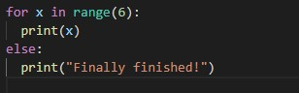

Nested Loops
A nested loop is a loop inside a loop.
The "inner loop" will be executed one time for each iteration of the "outer loop":

Example
Print each height for every form:
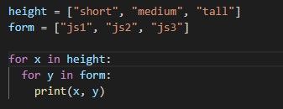

The pass Statement
for loops cannot be empty, but if you for some reason have a for loop with no content, put in the pass statement to avoid getting an error.

Example
